**The Refined Smart House - Security / Andrew Maddox**

AUTHORS:

(Primary Author)

Andrew Maddox

–Security Lead

(Team Members)

Ke’Ondrae Mell

-Project Lead

Garren Koller

-Lights and locks

Brandon Michelson

-Gateway Lead

Aaron Cooper

-Swarm Bots Lead

Dylan Crockett

-Security Member

Allan Dacoycoy

-Security Member

Camryn Vogel

-Security Member

Ryan Colixto

-Back end Lead

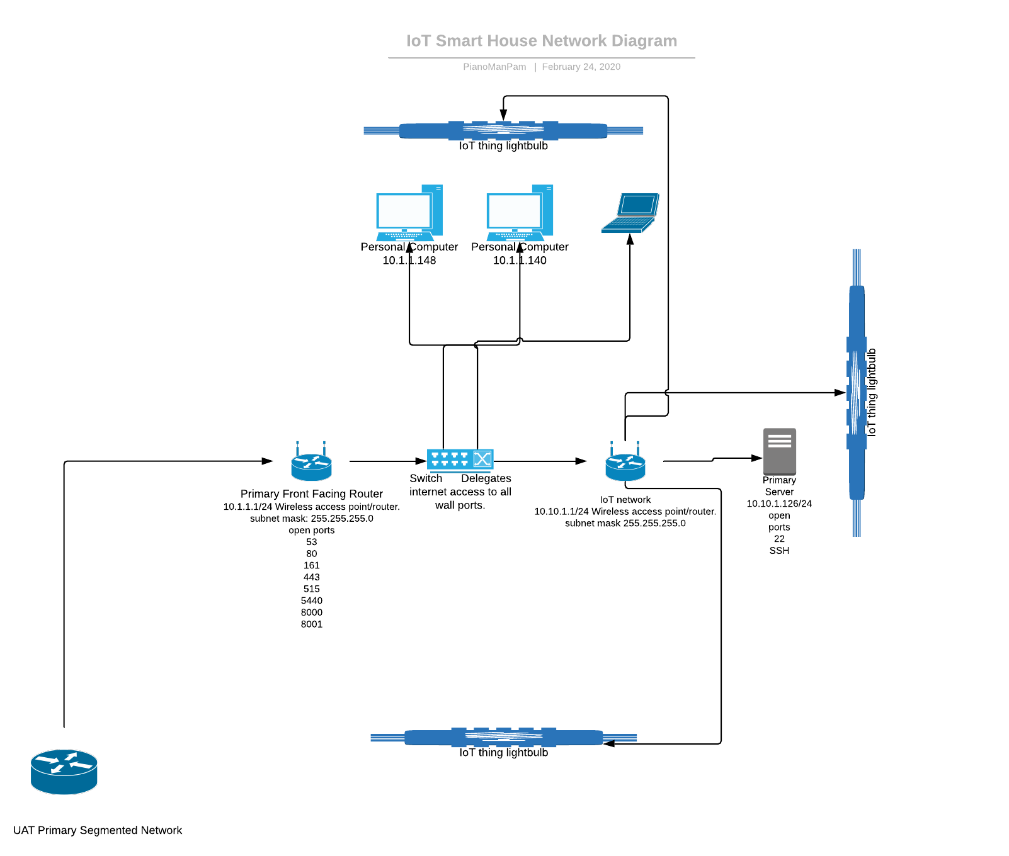**Subtitle (if necessary)**

**Technical Field**

The project creation involves the technical fields of Network Security and Network Engineering.

**Background Information**

This project was inspired by the lack of IoT security in homes today. Many personal encounters with individuals who have had little to no understanding of security but an excess of IoT lead me to this idea. Cheap solutions to network segmentation for IoT home networks are basically nonexistent. This cheap solution provides a segmented network without having to invest a mass amount of money on higher end hardware while paying for the network and the setup. This service provides not just the network setup structure but the setup process and the cheap solution tuned to each individual network.

**Prior Art**

Nortons 12 tips for securing smart homes. <https://us.norton.com/internetsecurity-iot-smart-home-security-core.html>

WS IoT Device Defender. <https://aws.amazon.com/iot-device-defender/>

IoT Defense company. <https://www.iotdef.com/>

Cisco IoT Threat Defense. https://www.cisco.com/c/en/us/solutions/security/iot-threat-defense/index.html

security of a single device in a specific way

This goes over the same topic in a sense but selectively focuses on one device and a violation of predetermined security rules being violated. This does not include any service involving security only specifics involving the security of a singular device.

[http://patft.uspto.gov/netacgi/nph-Parser?Sect1=PTO2&Sect2=HITOFF&p=1&u=%2Fnetahtml%2FPTO%2Fsearch-bool.html&r=4&f=G&l=50&co1=AND&d=PTXT&s1=%22IoT+security%22&OS=%22IoT+security%22&RS=%22IoT+security%22](http://patft.uspto.gov/netacgi/nph-Parser?Sect1=PTO2&Sect2=HITOFF&p=1&u=%2Fnetahtml%2FPTO%2Fsearch-bool.html&r=4&f=G&l=50&co1=AND&d=PTXT&s1="IoT+security"&OS="IoT+security"&RS="IoT+security")

“determination is made, based on the IoT data, as to whether the set of security rules has been violated. An alert is selectively sent based on the determination.”

This goes over encryption of local IoT devices and security involving the devices. Also mentioned is a security gateway and protection from external attacks. This is not covered much in depth whether this is a service security system or an all in one package. Differs from my current idea but close to the same concept.

[http://patft.uspto.gov/netacgi/nph-Parser?Sect1=PTO2&Sect2=HITOFF&p=1&u=%2Fnetahtml%2FPTO%2Fsearch-bool.html&r=50&f=G&l=50&co1=AND&d=PTXT&s1=%22IoT+security%22&OS=%22IoT+security%22&RS=%22IoT+security%22](http://patft.uspto.gov/netacgi/nph-Parser?Sect1=PTO2&Sect2=HITOFF&p=1&u=%2Fnetahtml%2FPTO%2Fsearch-bool.html&r=50&f=G&l=50&co1=AND&d=PTXT&s1="IoT+security"&OS="IoT+security"&RS="IoT+security")

Educational services and information on IoT patents. Both of these are for educational services and have some relation to the idea but do not infringe or come close to the current idea.

<http://tmsearch.uspto.gov/bin/showfield?f=doc&state=4802:2rqo5t.2.7>

<http://tmsearch.uspto.gov/bin/showfield?f=doc&state=4802:2rqo5t.2.4>

**Project Description**

The Refined Smart House project is a new take on IoT smart homes. The take includes network segmentation and aspects to IoT devices that have not been displayed in the industry before. The security aspect provides an environment setup that involves segmentation and individualized security to the specific environment. The outreach program / selling point would be individualized environments and adapting our infrastructure to their needs.

**Innovation Claim**

The innovation claim for this project is the security aspect that is being provided as a service. Incorporation all the factors being supplied including a localized system with communication with an on-site server that is secured and segmented from the network is a new innovation to the market. Most companies approach IoT from a face value and only provide the devices rather than security solutions. Taking an approach to a system bringing the IoT devices and the security aspect in an all in one service is innovative and has not been done to this extent. Most services existing is aimed towards environments that exist or small software solutions for typical environments with no real individualized service.

Having an attuned cheap approach to a home or small business involving IoT through conventional means that have not been implemented cannot be found on the market. This innovation could revolutionize the current IoT market with the current lack of IoT security awareness.

**Usage Scenario**

The primary usage would be implementation into homes and businesses. To elaborate on this the primary market would be wealthier homes seeking security in their IoT houses and businesses seeking an IoT environment that would be secure enough to implement and not risk the company. Smaller businesses with a rising concern in cyber security would be the initial market for the security side of this project. With further information delving into the intended market middle class, upper middle class, and richer individuals’ households will be the target residential market and medium size enterprises and up are the target company demographic.

**Evaluation Criteria**

I would evaluate this idea as a new innovation and claim to an already existing market solving a problem that already exists. Have you ever encountered an individual with an IoT based lock for their front door? If you have you have most likely thought about the security of the house with an internet based lock. Some malicious individual could in theory unlock your front door. This could be resolved by this solution as no downstream attacks could take place. Obviously, I would not be pursuing the idea if that were not the case as the ideas on both the front facing physical aspect and the security end pose new ideas to the topic at hand. IoT devices are such an upcoming idea and market and security is also a very large up and coming issue. Taking one issue and combining the solution with another topic results in a new innovation. This has not been approached in the same way that it is being approached in this scenario with the depth and concern of security.

**Objectives and Tasks Associated with the Project**

The objective for the security team is to create an IoT environment that is structurally safer from attacks then the primary usual IoT environment. The usual problem with typical IoT environments is no segmentation. Segmentation in any network is a good idea but promotes lateral movement in a network. Isolating IoT devices from your primary network / outward facing devices is a smart rule of thumb but can be cumbersome depending on the environment. The primary objectives will differ depending on the environment being handled but the main goal is to provide security to the environment being worked on.

Future Objectives

The primary objectives in our current run are to perform a pentest of the current network and assess the vulnerabilities or lack thereof in the environment. That is currently set out for this upcoming sprint at best time. Another objective is achieving encrypted communication between devices as to combat the biggest vulnerability with IoT, wireless pentesting and lateral movement from access wirelessly to IoT devices. Creating an outside access VPN for the network is also a goal for this semester but has not been fully fleshed out whether the benefits will outweigh the negatives for the network.

Previous Objectives

Previous objectives included setting up the core physical infrastructure. This included setting up the primary firewall, network segmentation, the original plan in general for the layout of the infrastructure and gaining access to the internet from the robotics lab. This objective was achieved, and the infrastructure has been functional since achieving this goal.

**Description of Design Prototype**

The prototype is the infrastructure that has been put into place for the IoT Smart House. This infrastructure is a proof of concept/fully functional prototype for this outsourcing of smart home security. The current location of the prototype has been built in the Engineering Lab (Robotics Lab) and currently runs in correlation with the IoT devices. There are not specific directions to the prototype as the prototype is an extensive all encompassing situation. There is further extensive documentation on each different aspect of the project upon request.

**Evaluation Plan**

The evaluation Criteria has already been achieved in the aspect of creation of the project itself. Achieving a new take on IoT security with the lack of security in the IoT is being achieved through cheap and useful means. The primary Ubuntu Server is being used to handle centralized communication that does not reach outside the Demilitarized Zone while keeping internet access. Through double NAT and a segmentation network design upstream connection is allowed but downstream connection is not in a sense making the IoT network a separate area of the network. This solution has not been implemented in homes or businesses available today. To further this plan in the future any small changes that could improve security and efficiency further that has not already been implemented will be implemented.

**Project Completion Assessment**

The project has been for the most part completed with a current delay given certain circumstances at the given moment. The infrastructure is functional and further research and time has been put into how it works and how to convey how it works. There were some instances of outages and permissions issues where individuals who were not supposed to changed something that should not have been. Throughout the process the conveying of information and further understanding of a product have been the main things learned. If you do not know how to properly convey information on an extensive technical aspect to potential investors then you might run into issues. The innovation of the project was there when the idea was being formed but it has really blossomed as further thoughts have been formed on why the importance value exists and how it’s being solved. Today there is no solution much like what is being proposed on an affordable scale for homes and businesses.

**Appendices**

Appendix A: IoT Smart House Network Diagram – diagram.png.

Appendix B: Educational Patents Related to Project - <http://tmsearch.uspto.gov/bin/showfield?f=doc&state=4802:2rqo5t.2.7>

<http://tmsearch.uspto.gov/bin/showfield?f=doc&state=4802:2rqo5t.2.4>

Appendix C: Specific Patent Over Encryption of Local Devices - [http://patft.uspto.gov/netacgi/nph-Parser?Sect1=PTO2&Sect2=HITOFF&p=1&u=%2Fnetahtml%2FPTO%2Fsearch-bool.html&r=50&f=G&l=50&co1=AND&d=PTXT&s1=%22IoT+security%22&OS=%22IoT+security%22&RS=%22IoT+security%22](http://patft.uspto.gov/netacgi/nph-Parser?Sect1=PTO2&Sect2=HITOFF&p=1&u=%2Fnetahtml%2FPTO%2Fsearch-bool.html&r=50&f=G&l=50&co1=AND&d=PTXT&s1="IoT+security"&OS="IoT+security"&RS="IoT+security")

Appendix D: Security Rules Regulation Similar but not Related Completely to Project - [http://patft.uspto.gov/netacgi/nph-Parser?Sect1=PTO2&Sect2=HITOFF&p=1&u=%2Fnetahtml%2FPTO%2Fsearch-bool.html&r=4&f=G&l=50&co1=AND&d=PTXT&s1=%22IoT+security%22&OS=%22IoT+security%22&RS=%22IoT+security%22](http://patft.uspto.gov/netacgi/nph-Parser?Sect1=PTO2&Sect2=HITOFF&p=1&u=%2Fnetahtml%2FPTO%2Fsearch-bool.html&r=4&f=G&l=50&co1=AND&d=PTXT&s1="IoT+security"&OS="IoT+security"&RS="IoT+security")

Appendix E: Cisco IoT Defense Product - https://www.cisco.com/c/en/us/solutions/security/iot-threat-defense/index.html

Appendix F: IoT Defense Product - <https://www.iotdef.com/>

Appendix G: Amazon AWS Defense Product - <https://aws.amazon.com/iot-device-defender/>

Appendix H: Norton Tips on IoT Security - <https://us.norton.com/internetsecurity-iot-smart-home-security-core.html>